Decoders, Multiplexers, Demultiplexers.

Textbook P&H: Ch. 4.5, Appendix B, http://www.play-hookey.com

- Goal – Teach students the functionality and the usage of decoders, multiplexers, demultiplexers.
- Learning outcome - by the end of this class the students should be able to create a simple decoders, multiplexers, demultiplexers and schematics to use them.

Decoders

Decoders are used for forming separate signals for different combination of input signals.
If we want to build full 2 bit decoder on 2 - A and B variables then we have to get all 4 signals for all 4 combinations of input variables on the output of circuit.
Below is the decoders sign for schematics.

A | B | F0 | F1 | F2 | F3
0 | 0 | 1
0 | 1 |  | 1
1 | 0 |  |  | 1
1 | 1 |  |  |  | 1

F0 = A’ B’, F1 = A’ B, F2 = A B’, F3 = A B

2 bit decoder
A
B
F0
F1
F2
F3

We know how to implement 4 different functions of the same variables.

2 bit decoder

A

B
&
&
&
&

F0 = A’ B’

F1 =A’ B

F2 = A B’

F3 = A B

A

B

F0

F1

F2

F3

The 3 bit decoder decodes all 8 possible values of ABC variables to the different 8 signals on the output. All outputs are in inactive (in this case logical 0) state and only one output is activated appropriate to the input code. So at every moment we have only one output line activated.

3 bit decoder

A

F0 - 000

F1 - 001

F2 - 010

B

F3 - 011

F4 - 100

C

F5 - 101

F6 - 110

F7 - 111

This behaviour is very useful for creating Control Unit’s different circuits.
If we have 3 bit binary counter and 3 bit decoder then we can organize the simple cycle of 8 clocks doing necessary operations in simple CPU.
Let’s try to use some Control Unit which gives signals to implement the Basic Machine Cycle.
Fetch Instruction

3 bit binary counter
0
1

3 bit decoder

6
7

A
Increment Program Counter

Decode Instruction to execute it

B
Put 1st Operand into ALU (R1)

C
Put 2nd Operand into ALU (R2)
Do ALU operation (add, sub)

Clock
Take the result from ALU

Put the result from ALU to R3

Multiplexers

The 2 input multiplexer

The multiplexer circuit is a digital circuit with multiple signal inputs, one of which is selected by separate address inputs to be sent to the single output.

A two-input multiplexer is shown below.

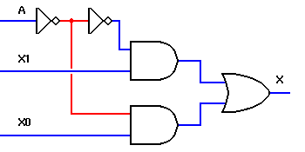  A  X1  X0 | A  2 bit  Multiplexer  X
  A =0 | X=X0
  A =1 | X=X1

The multiplexer circuit is typically used to combine two or more digital signals onto a single line, by placing them there at different times. Technically, this is known as time-division multiplexing.
Input A is the addressing input, which controls which of the two data inputs, X0 or X1, will be transmitted to the output. If the A input switches back and forth at a frequency more than double the frequency of either digital signal, both signals will be accurately reproduced, and can be separated again by a demultiplexer circuit synchronized to the multiplexer.

This is not as difficult as it may seem at first glance; the telephone network combines multiple audio signals onto a single pair of wires using exactly this technique, and is readily able to separate many telephone conversations so that everyone's voice goes only to the intended recipient. With the growth of the Internet and the World Wide Web, most people have heard about T1 telephone lines. A T1 line can transmit up to 24 individual telephone conversations by multiplexing them in this manner.

Multiplexers are not limited to two data inputs. If we use two addressing inputs, we can multiplex up to four data signals. With three addressing inputs, we can multiplex eight signals.

The 4 input multiplexer

The multiplexer concept is not limited to two data inputs. If we add a second addressing input, B, we can control as many as four data inputs. A third and fourth addressing input will allow the multiplexer to control eight or sixteen inputs, respectively.

Inputs A and B are the addressing inputs to this multiplexer. They select which of the four data inputs will be transmitted to the final output, X.

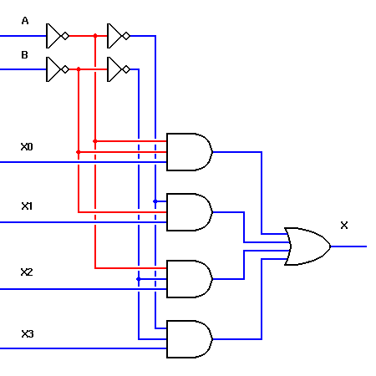  X3  X0  X2  X1 | A  B  4 bit  Multiplexer  X
  BA =00 | X=X0
  BA =01 | X=X1
  BA =10 | X=X2
  BA =11 | X=X3

Demultiplexers

The 1-to-2 line decoder demultiplexer

The opposite of the multiplexer circuit, logically enough, is the demultiplexer. This circuit takes a single data input and one or more address inputs, and selects which of multiple outputs will receive the input signal. The same circuit can also be used as a decoder, by using the address inputs as a binary number and producing an output signal on the single output that matches the binary address input. In this application, the data input line functions as a circuit enabler — if the circuit is disabled, no output will show activity regardless of the binary input number.

A one-line to two-line decoder/demultiplexer is shown below.
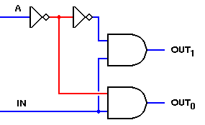 | A  1 to 2 bit Demultiplexor  IN  Out 1  Out 0
  A=0 | Out0=IN
  A=1 | Out1=IN

This circuit uses the same AND gates and the same addressing scheme as the two-input multiplexer circuit shown in these pages. The basic difference is that it is the inputs that are combined and the outputs that are separate. By making this change, we get a circuit that is the inverse of the two-input multiplexer. If you were to construct both circuits on a single breadboard, connect the multiplexer output to the data IN of the demultiplexer, and drive the (A)ddress inputs of both circuits with the same signal, you would find that the initial X0 input would be transmitted to OUT₀ and the X1 input would reach only OUT₁.

The one problem with this arrangement is that one of the two outputs will be inactive while the other is active. To retain the output signal, we need to add a latch circuit that can follow the data signal while it's active, but will hold the last signal state while the other data signal is active. An excellent circuit for this is the D (or Data) Latch. By placing a latch after each output and using the Addressing input (or its inverse) to control them, we can maintain both output signals at all times. If the Address input changes much more rapidly than the data inputs, the output signals will match the inputs faithfully.

The 2 to-4 line decoder demultiplexer

Like the multiplexer circuit, the decoder/demultiplexer is not limited to a single address line, and therefore can have more than two outputs. With two, three, or four addressing lines, this circuit can decode a two, three, or four-bit binary number, or can demultiplex up to four, eight, or sixteen time-multiplexed signals.

As a decoder, this circuit takes an n-bit binary number and produces an output on one of 2^{n} output lines. It is therefore commonly defined by the number of addressing input lines and the number of data output lines.

Typical decoder/demultiplexer ICs might contain two 2-to-4 line circuits, a 3-to-8 line circuit, or a 4-to-16 line circuit.

If you use this circuit as a demultiplexer, you may want to add data latches at the outputs to retain each signal while the others are being transmitted. However, this does not apply when you are using this circuit as a decoder — then you will want only a single active output to match the input code.

A 2-to-4 line decoder/demultiplexer is shown below.

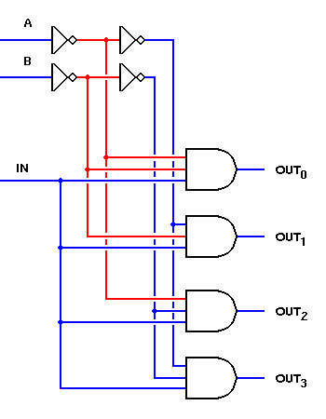  IN | A  B  Out 0  2 to 4 bit Demultiplexor  Out 1  Out 2  Out 3
  BA =00 | Out0=IN
  BA =01 | Out1=IN
  BA =10 | Out2=IN
  BA =11 | Out3=IN

Below is shown the simple usage of Multiplexers in computers.

There is shown the MIPS like processor example. The difference is that we have only 4 General Purpose Registers and appropriately only 2 bits we need in instructions to define the Registers.

That is why in MIPS like “sw” 16 bit instruction we have “rt” register defined by only two bits and equal to “10₂” in this concrete case.
The sw instruction has to store the contents of Register 2 (10₂) into the some memory address (not important in this case).

Registers have 32 bits as in MIPS.
The logic elements have only two states - zero, one (no high impedance).

There are 32 Data Multiplexers. Each Multiplexer passes one bit. Mx0 has all 4 0th bits coming from 4 Registers and passes only one of them to the output. Mx1 passes only bit 1st of 4 registers. The Mx31 accepts the 4 31st bits of 4 Registers but passes only one of that bits to the output.

Two bits from rt field switch all 32 Data Multiplexers forcing them to pass only 32 bits of 2nd register to the memory Data Register.
sw rt, address
sw $2, 0($3)
0x2b | base | rt | Offset
10 1011 | 11 | 10 | 000000

31

R
0

0

31

R
1

0

31

R
2

0

Instruction Register

rt[0]
rt[1]

31

Da t a

Reg

0

Memory

31

R
3

0
Mx 31

Mx 0

Many Registers to One without high impedance state
(only logical 0 and 1)

For implementation of the “lw” instruction we need Decoders for each register. Decoder’s each output provides a signal for appropriate General Purpose Register to accept the data from the Date Register’s output.
Which General Purpose Register is selected is defined again by two bits of Instruction Register’s “rt” field.

lw rt, address
lw $2, 0($3)
0x2b | base | rt | Offset
10 1011 | 11 | 10 | 000000

Instruction Register

Decoder

Memory

Da t a

Reg

Reg

3

Reg

2

Bus

R

eg

1

One Register to Many

Reg

0

With the “high impedance” or three-state logic it’s possible to keep the output of registers in the state of high impedance (practically disconnected from the Bus). Only the 2nd register which gets the signal of connection from the decoder will connect its output to the Bus thus providing its content through the Bus to the Data Register.

sw rt, address
sw $2, 0($3)
0x2b | rs | rt | Offset
10 1011 | 11 | 10 | 000000

Instruction Register

Decoder

Memory

Da t a

Reg

Reg

3

Reg

2

Bus

R

eg

1

Many Registers to One with high impedance state

Reg

0

